

**Placement Empowerment Program**

**Cloud Computing and DevOps Centre**

Set Up a Private Network in the Cloud - Create a Virtual Network with subnets for your instances. Configure routing for internal communication between subnets.

Name: Aksha S Department: CSE

Step 1:

Login to Azure portal and create a Virtual Network

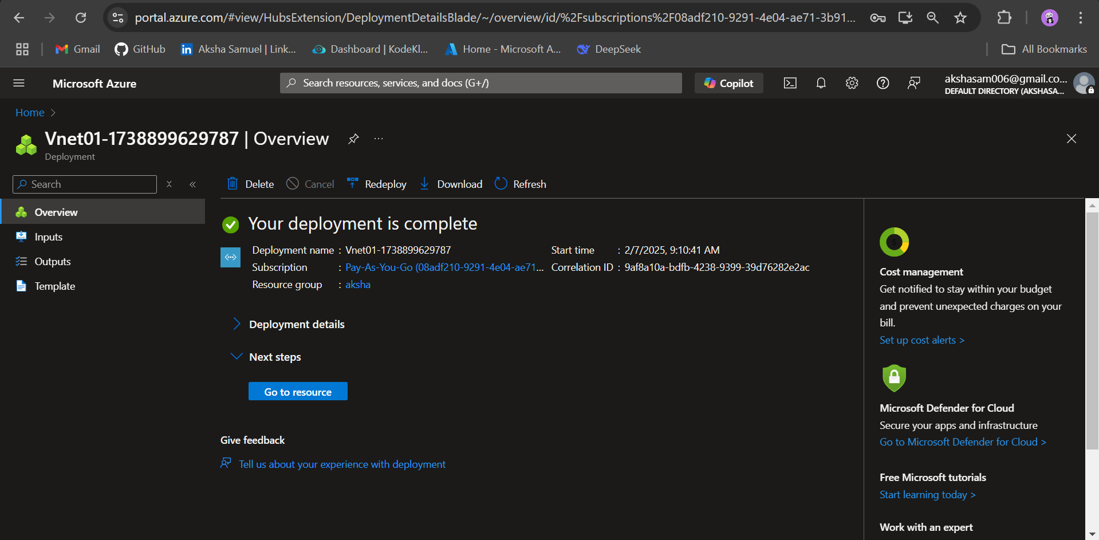

Step 2:

Create 2 subnets under Virtual Network that was created in the previous step

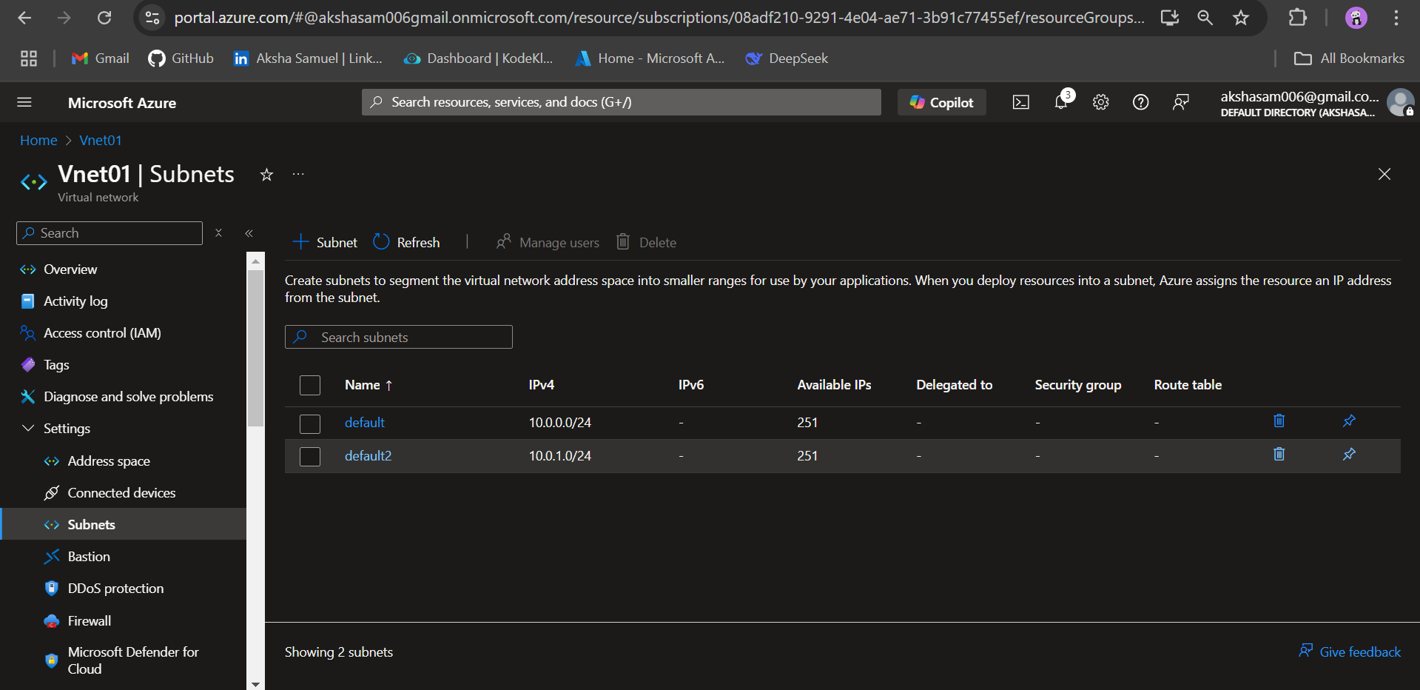

Step 3:

Set Up Routing for Internal Communication

Create Route Tables

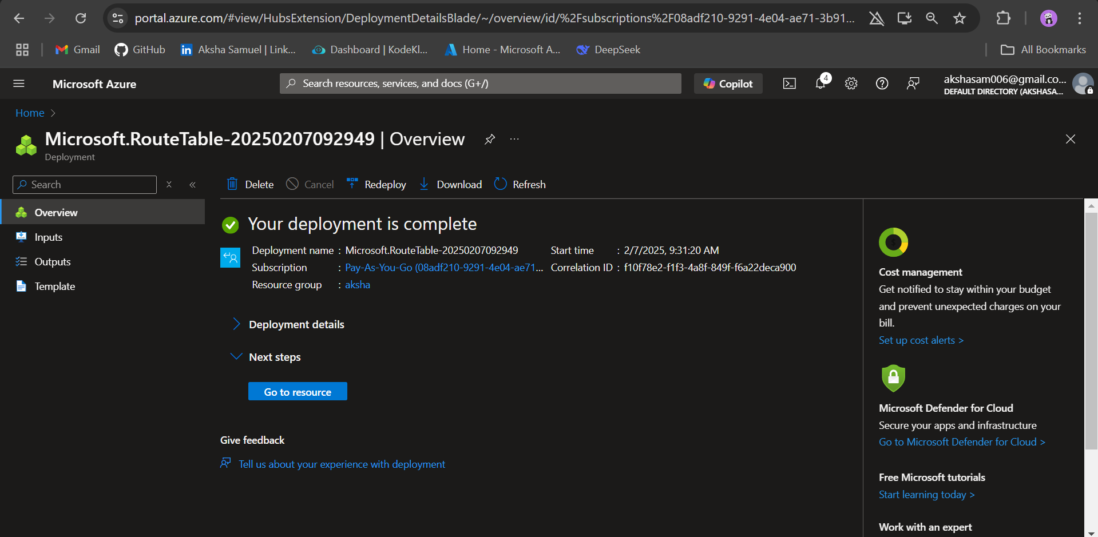

Step 4:

Associate the subnet in the route tables

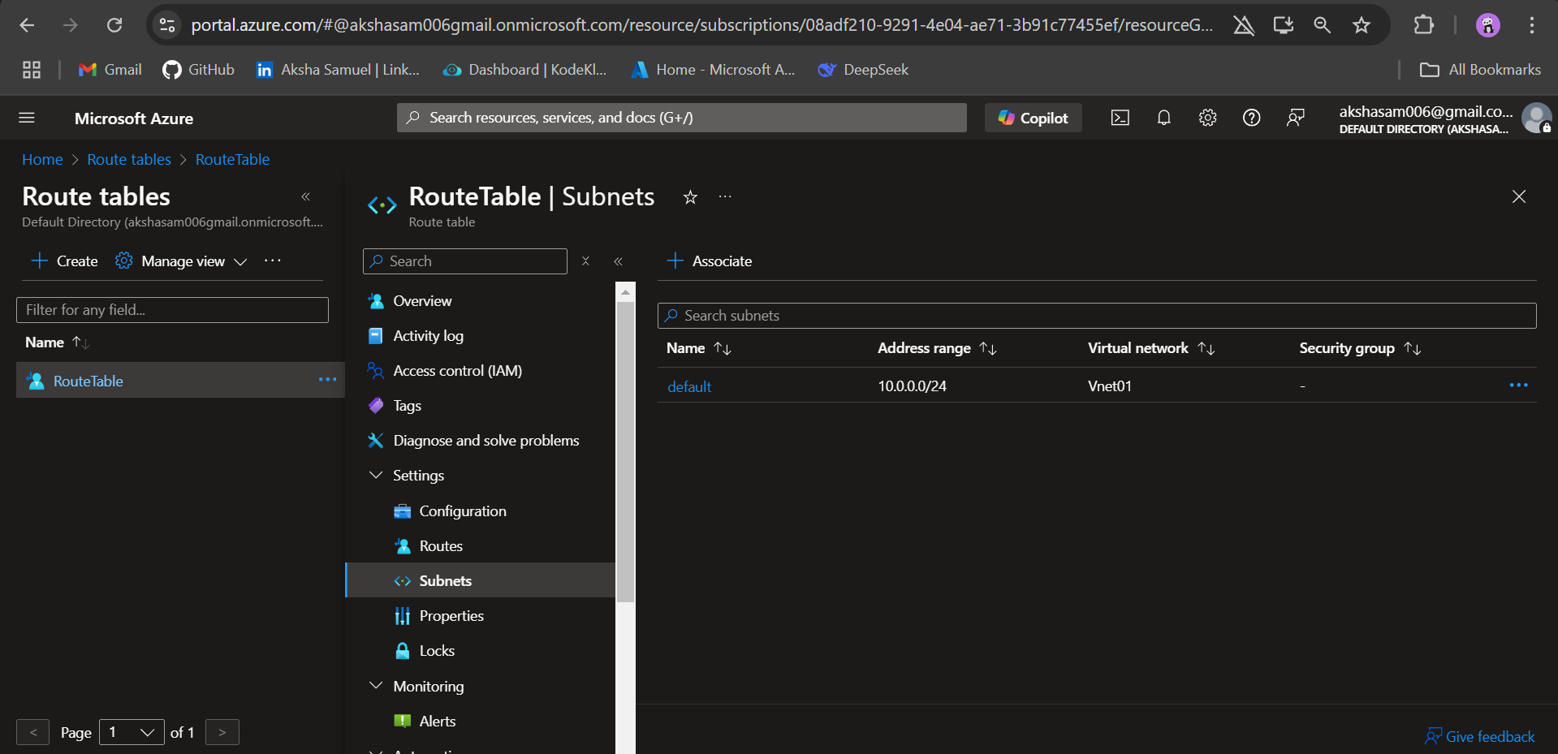

Step 5:

Deploy a NAT Gateway

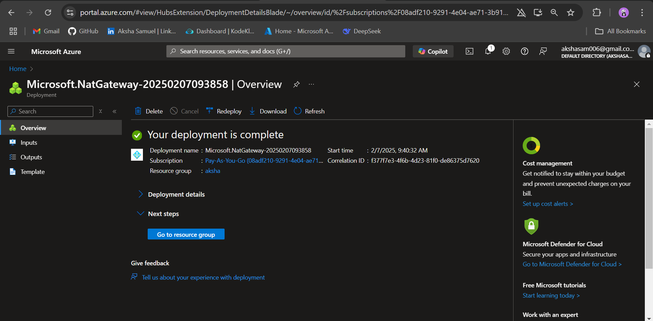

Step 6:

Deploy a Virtual Machine in public subnet

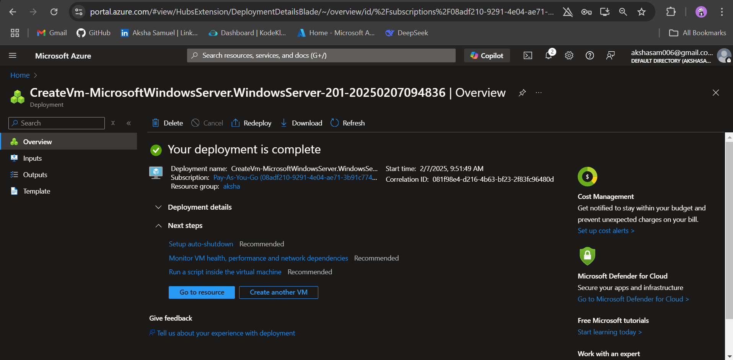

Step 7:

Deploy a Virtual Machine in private Subnet

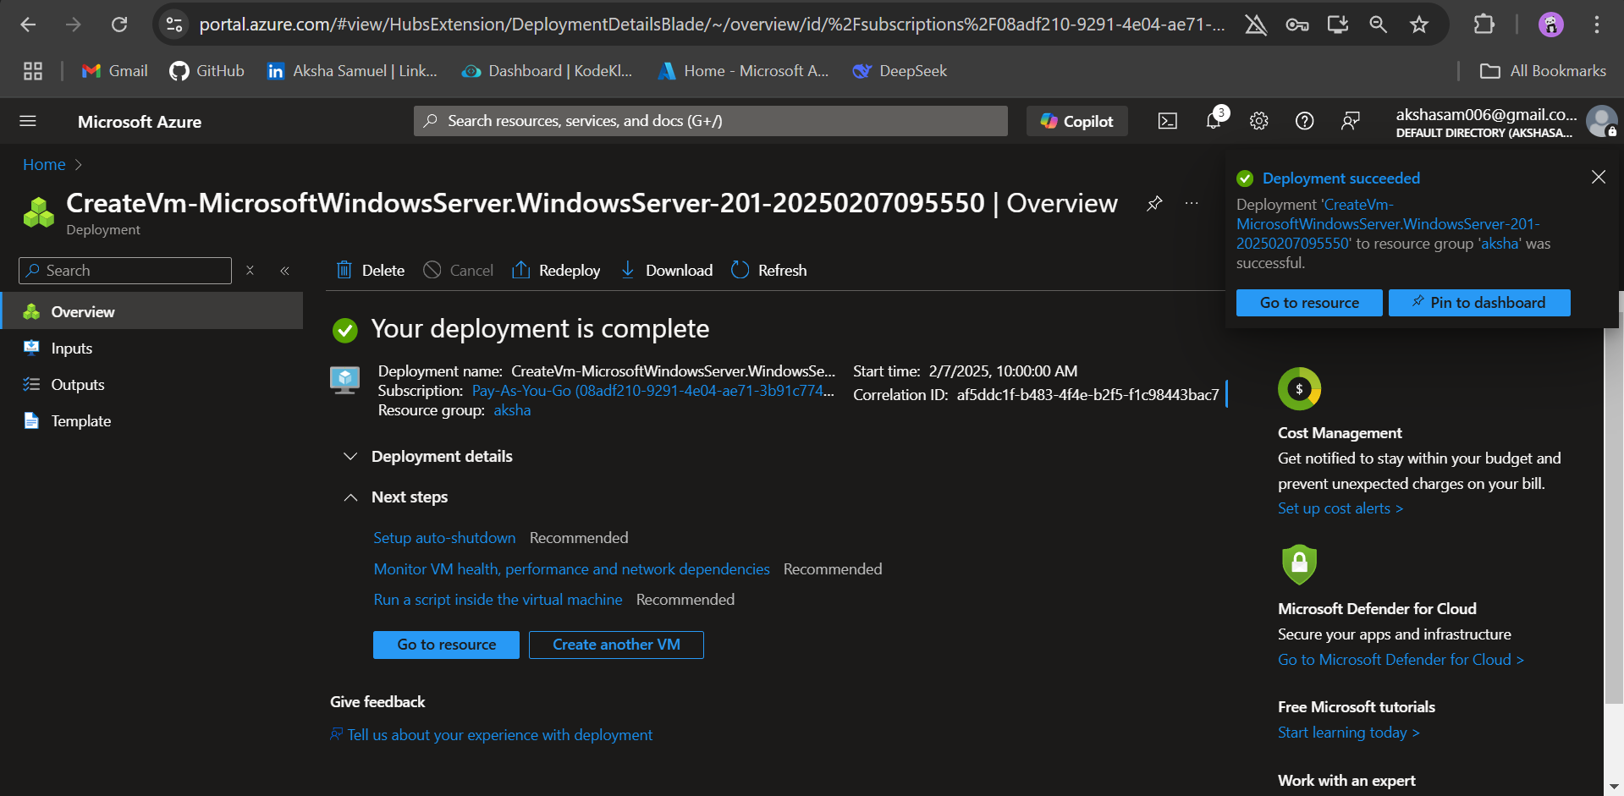

Step 8:

Test communication SSH or RDP into a Virtual Machine in default Subnet. Try pinging another Virtual Machine in default2 Subnet.